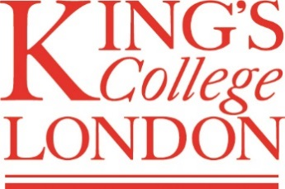
2016 SUMMER SCHOOL APPLICATION FORM:
Undergraduate
SUMMER SCHOOL
27 June–15 July and 18 July–5 August 2016

CURRENT KING’S LIBERAL ARTS STUDENTS
Please fill in the required information below and email your completed application form to the Summer School Admissions Officer – fahema.ettoubi@kcl.ac.uk – with a clear subject line: King’s Internal Application: your name

personal details
First name: Click here to enter text. |  | Surname: Click here to enter text.
Date of birth: Click here to enter text. |  | Contact telephone number: Click here to enter text.
Email address: Click here to enter text.
Correspondence address: Click here to enter text.
City: Click here to enter text. | County: Click here to enter text. |  | Postcode: Click here to enter text.

King’s college london information
Current degree programme: Click here to enter text.
Current year of study: Click here to enter text.
SITS number: Click here to enter text.

summer school 2016 application
Which session do you wish to apply for? (please indicate in the appropriate box below)
Session 1:  27 June – 15 July ☐ | Session 2:  18 July – 5 August ☐ |  | Session 1+2:  27 June – 5 August ☐
Please indicate your preferred module choice for each session you are applying for:

Session 1: Click here to enter text.
Session 2: Click here to enter text.

Thank you for completing this application form. Once you have submitted your application you should receive a response from our Admissions team within 7 working days.

